Hindustan college of science and technology

Farah, Mathura



***MINI PROJECT (KCS554)***

**SUBMITTED BY: SUBMITTED TO: -**

**NAME: - Tushar Sarin, MRS. SANJANA**

**Vikas Singh Rathore**

**ROLL NO.: - 1806410116,**

**1806410121**

**BRANCH: - COMPUTER SCIENCE ENGG.**

**TABLE OF CONTENT**

1. **Introduction**
   1. **Overview**
   2. **Background and Motivation**
2. **Technology used**
   1. **User Interface**
   2. **Software Required**
   3. **Hardware Required**
   4. **System Requirements**
3. **Features of Projects**
4. **Snapshots**
5. **Source code**
6. **Conclusion and Future Scope**

**INTRODUCTION**

**Overview: -**

This report discusses the result of the work done in development of “Shop’s Inventory Management System/Billing/Invoice Software” using Python with Saving Invoice with every unique invoice number in Background (Given location).

**Background and Motivation:-**

This project is very popular and widely used in many big organizations for submitting various types of bills to their customers and to their seniors. This is the system which can maintain most of the activities in big organizations. This project is aimed at developing a system by which the employees in the organization submit the bills to their managers or to the customers. The employee after submitting the bill will automatically saves in the background at which the location is provided. The bill will pass through a workflow process and the owner of the bill or bill creator can view the status of the bill at any time.

The Motivation of this project is aimed at developing a system which reduces work burden of employees of the organization. Every Organization has some maintenance and budget planning’s. in this situation submitting bills to their corresponding mangers will be a headache and we must maintain records manually. Sometimes in manual process there is a possibility to get errors. To overcome these difficulties and time being best to use this type of application. In this the employee in the organization submit the bills to their managers. The bills could of various types and of various amounts. The employee after submitted. The bill will pass through a workflow process and the owner of the bill can view the status of the bill at any time. An email will be sent to the concerned people to let them know about the status of the bill.

**TECHNOLOGY USED**

**User Interface:-**

In the flexibility of the uses the interface has been developed a graphics concept in mind, associated through a browses interface. The GUI’s at the top level have been categorized as

* + 1. Administrative user interface
    2. The operational or generic user interface

**Software Required:-**

1. Windows OS
2. Python 3.9.1

**Hardware Required:-**

1. Processor (intel core i3 or raspberry pi)
2. RAM 512GB and Above
3. Storage (HDD or SSD) 20GB and Above

**FEATURES OF PROJECT**

The best billing software for your business should carry the following features:

1. Creation of New Invoice:-

An invoice billing software allows creation of clean and professional invoices that can be customized to match the brand the business owns. The software should allow extracting and integrating information from projects, timesheets, and customer records.

### Creating Costumer Record:-

### A billing software for small businesses enables you to summarize customers’ personal and purchase information and attach relevant files in a single, centralized database equipped with search filters for easy access to customer records. Also it should be an offline billing software to enable users to work even when internet is down.

### Invoice, payment, and Tax report:-

### A good online billing software should eliminate the need for you to use external systems for tax reporting and allow you to perform it within the same system, without losing hours to summarize information.

1. The ability to add company logo and free text messages.
2. To option to submit electronic and/or printed bills.
3. Allow for unit price and total to show in multiple currencies.
4. High encrypted security feature for all financial data submitted electronically.
5. The option to save and/backup in the cloud or server.
6. The ability to create recurring bills.
7. The ability to create encrypted codes for each invoice (in addition to invoice numbers) for reconciliation.
8. the ability to track invoices by customer.

**SNAPSHOTS**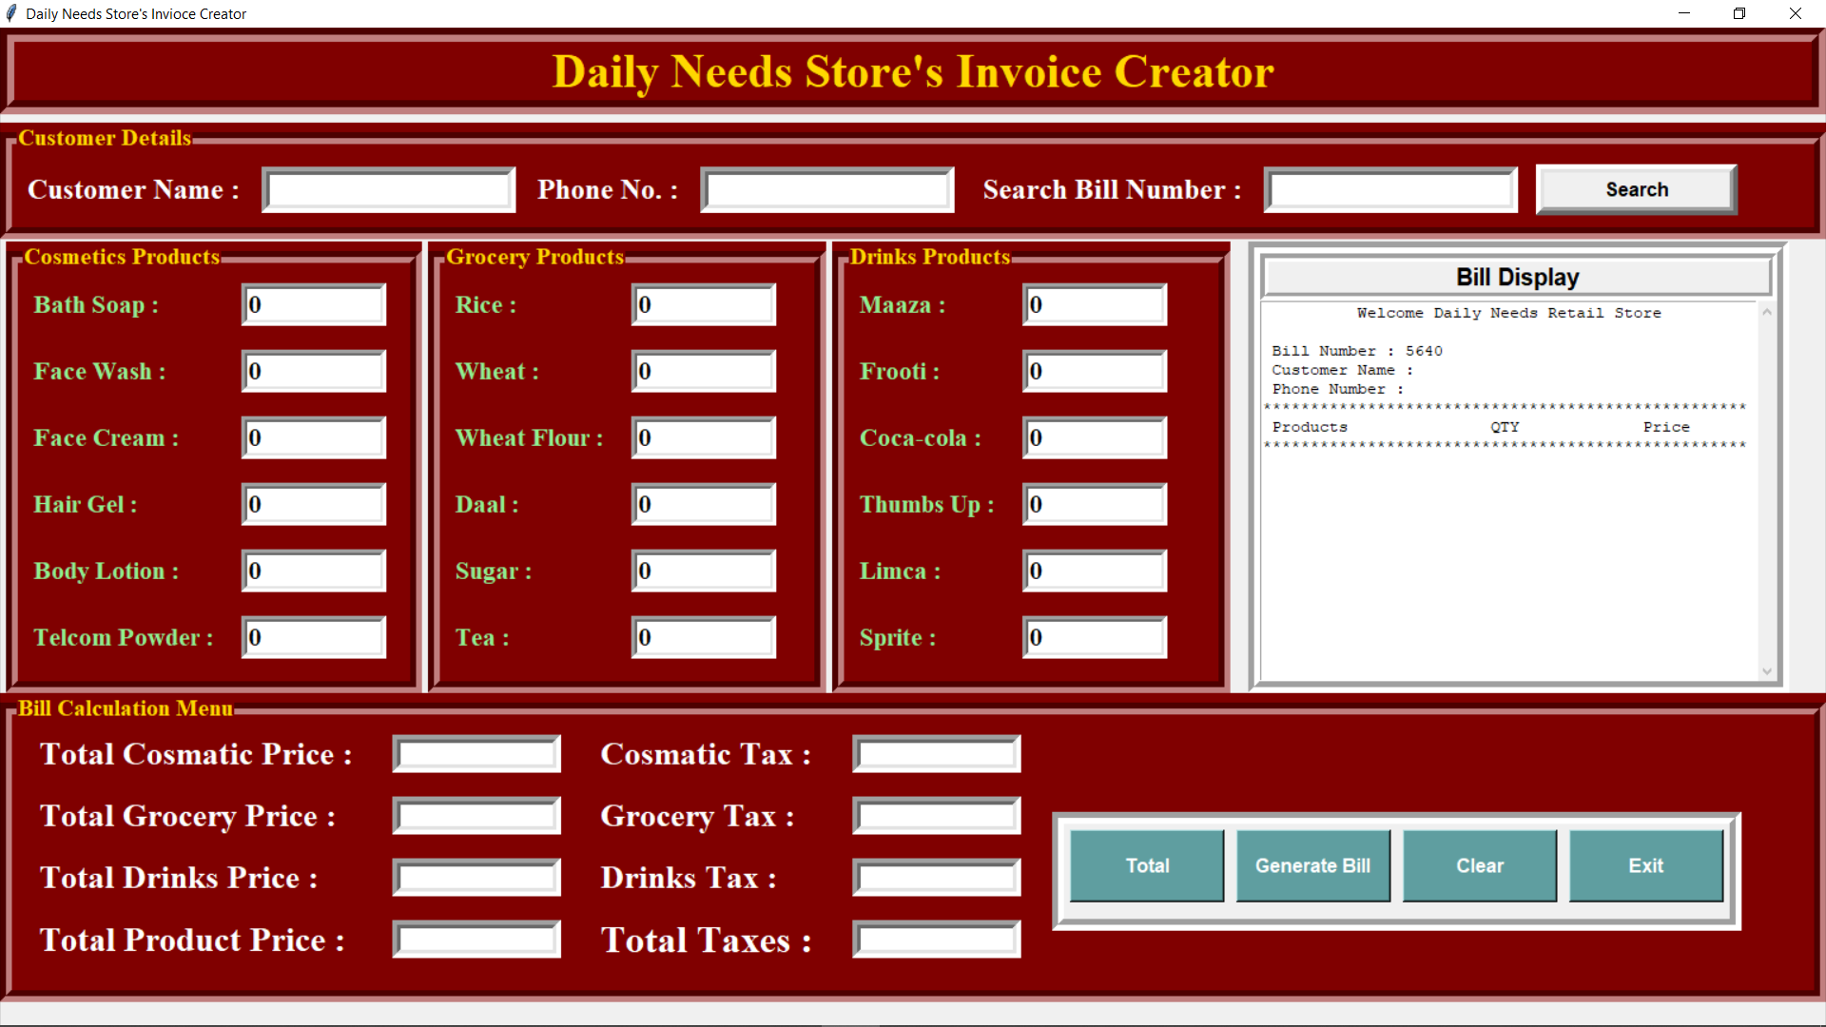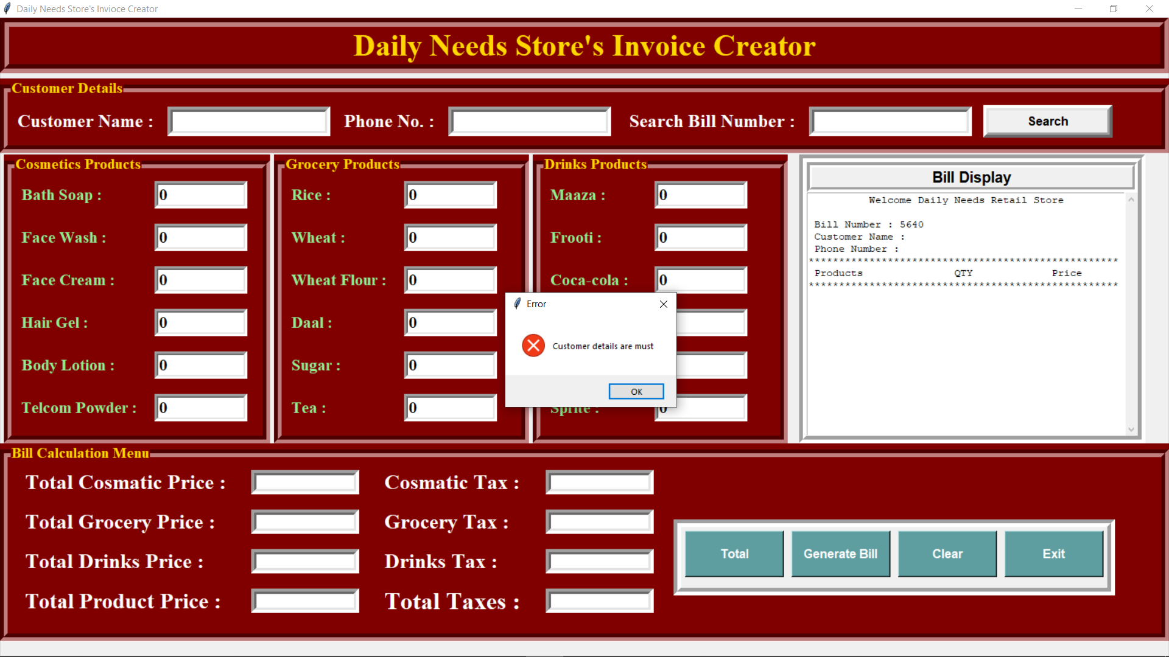 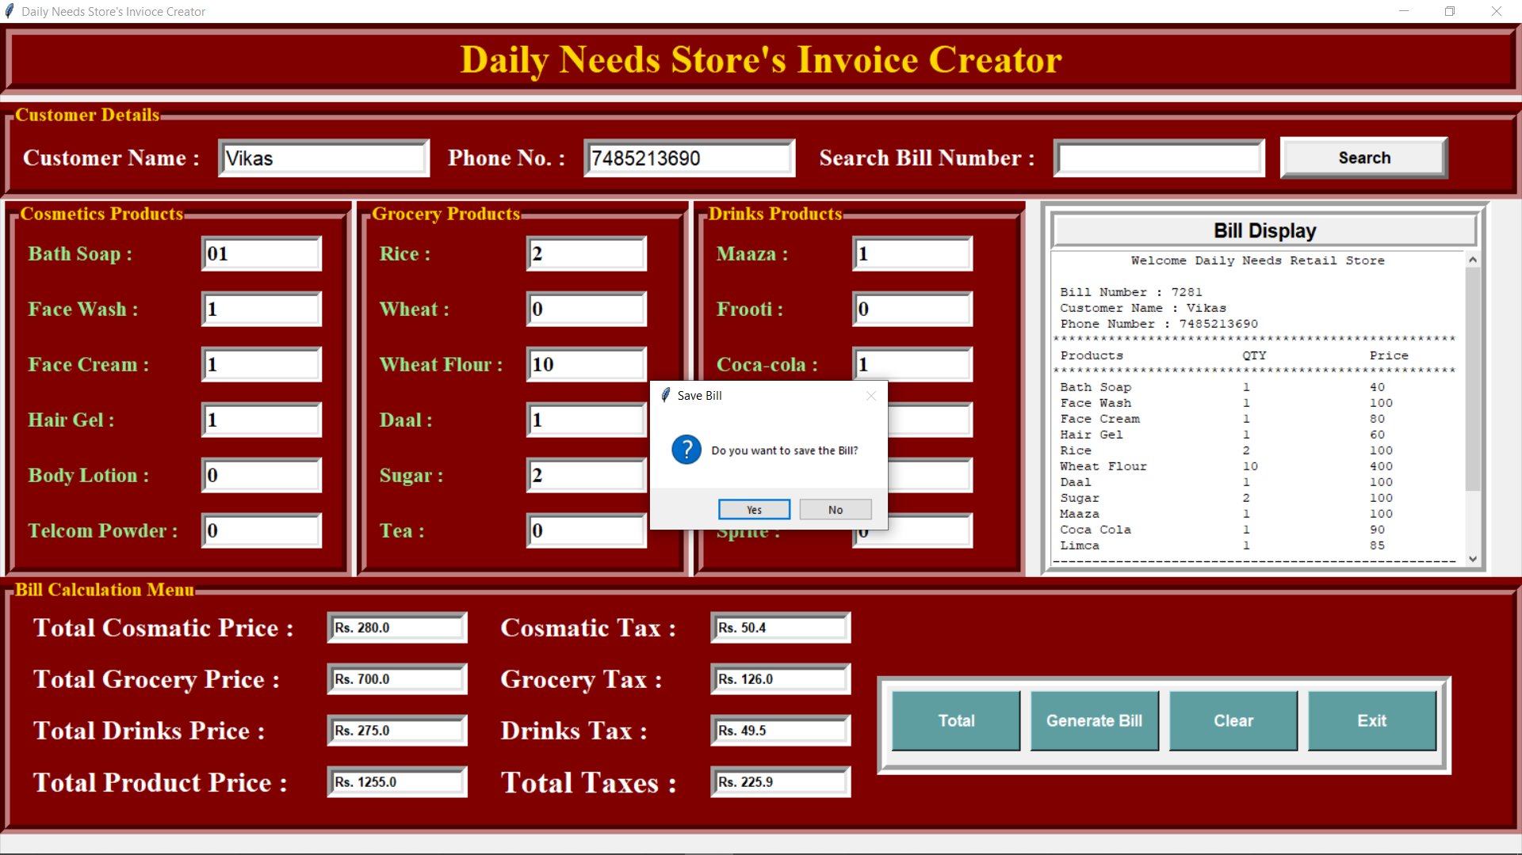 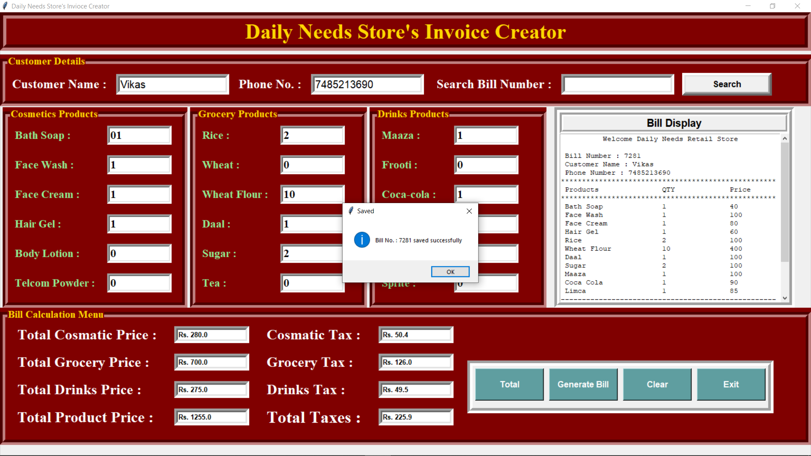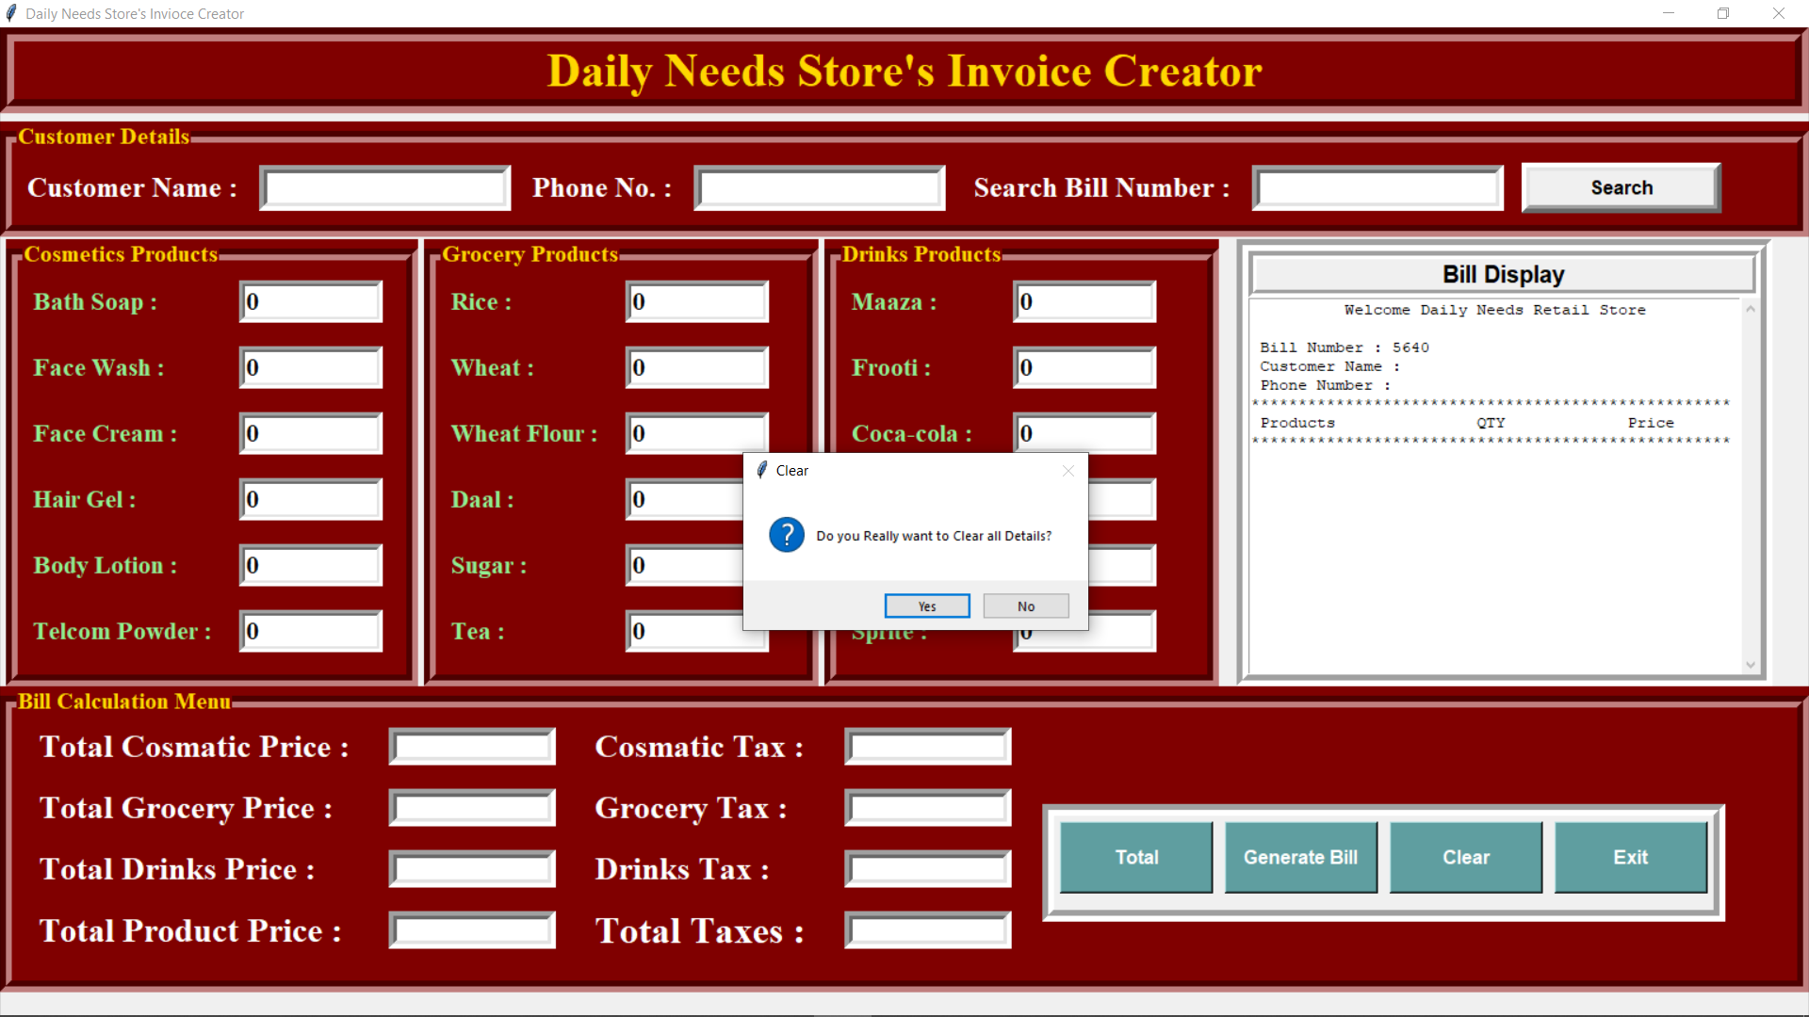 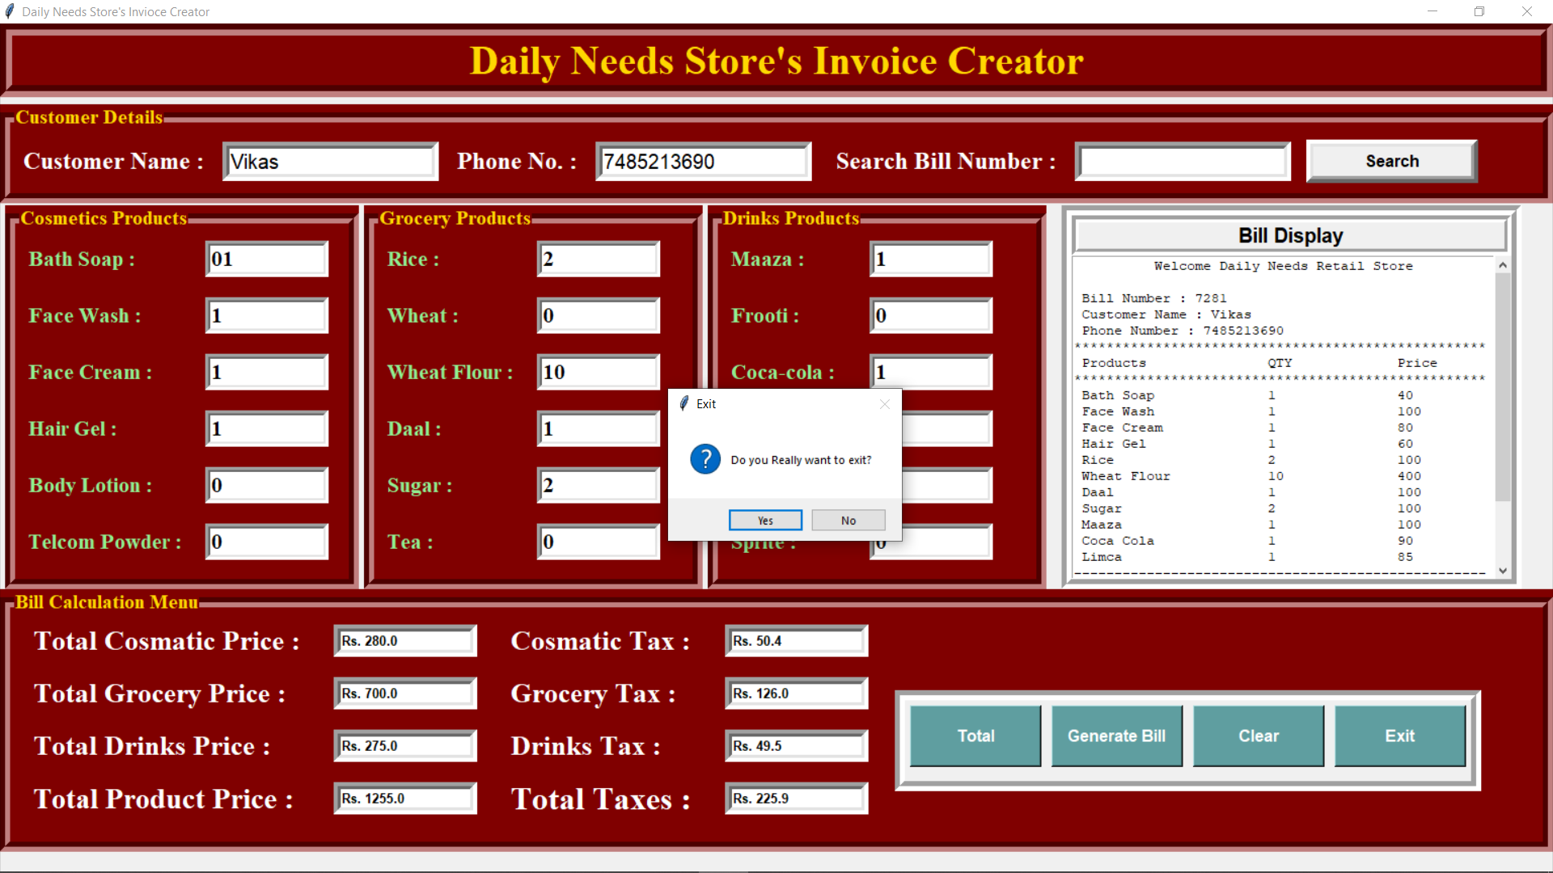

**SOURCE CODE**

from tkinter import *

import math

import random,os

from tkinter import messagebox

class Bill_App:

def __init__(self,root):

self.root=root

self.root.geometry("1520x820+0+0")

self.root.title("Daily Needs Store's Invioce Creator ")

bg_color="maroon" #maroon color

title=Label(self.root,text="Daily Needs Store's Invoice Creator",bd=12,relief=GROOVE,bg=bg_color,fg="gold",font=("times new roman",30,"bold"),pady=2).pack(fill=X)

#---------------------Variable-----------------------------------------

#------------------Cosmetics Variable-----------------------

self.soap=IntVar()

self.face_cream=IntVar()

self.face_wash=IntVar()

self.powder=IntVar()

self.gel=IntVar()

self.lotion=IntVar()

#----------------------------------Grocery Variable---------------------------------

self.rice=IntVar()

self.wheat=IntVar()

self.wheat_flour=IntVar()

self.daal=IntVar()

self.sugar=IntVar()

self.tea=IntVar()

#--------------------------Drinks Variables-----------------------

self.maaza=IntVar()

self.frooti=IntVar()

self.coca_cola=IntVar()

self.thumps_up=IntVar()

self.limca=IntVar()

self.sprite=IntVar()

#-----------------------Total Products Variable---------------------------------------------

self.cosmetic_price=StringVar()

self.grocery_price=StringVar()

self.drinks_price=StringVar()

#-----------------Tax Variables----------------------------

self.cosmetic_tax=StringVar()

self.grocery_tax=StringVar()

self.drinks_tax=StringVar()

#------------------Total Prices Variable---------------------------------------

self.total_product_price=StringVar()

self.total_tax=StringVar()

self.total_bill_price=IntVar()

#---------------------------------------Customer Variable-------------------------

self.c_name=StringVar()

self.c_phone=StringVar()

self.bill_no=StringVar()

x=random.randint(1000,9999)

self.bill_no.set(str(x))

self.search_bill=StringVar()

#-------------------Customer Details Frame---------------

F1=LabelFrame(self.root,text="Customer Details",bd=10,relief=GROOVE,font=("times new roman",15,"bold"),fg="gold",bg=bg_color)

F1.place(x=0,y=80,relwidth=1)

cname_label=Label(F1,text="Customer Name :",bg=bg_color,fg="white",font=("times new roman",18,"bold")).grid(row=0,column=0,padx=10,pady=10)

cname_text=Entry(F1,width=18,textvariable=self.c_name,bd=7,relief=SUNKEN,font=("ariel",15)).grid(row=0,column=1,padx=5,pady=10)

cphone_label=Label(F1,text="Phone No. :",bg=bg_color,fg="white",font=("times new roman",18,"bold")).grid(row=0,column=2,padx=10,pady=10)

cphone_text=Entry(F1,width=18,textvariable=self.c_phone,bd=7,relief=SUNKEN,font=("ariel",15)).grid(row=0,column=3,padx=5,pady=10)

cbill_label=Label(F1,text=" Search Bill Number :",bg=bg_color,fg="white",font=("times new roman",18,"bold")).grid(row=0,column=4,padx=10,pady=10)

cbill_text=Entry(F1,width=18,textvariable=self.search_bill,bd=7,relief=SUNKEN,font=("ariel",15)).grid(row=0,column=5,padx=5,pady=10)

bill_btn=Button(F1,text="Search",command=self.find_bill,width=15,bd=7,font=("ariel",12,"bold")).grid(row=0,column=6,padx=10,pady=10)

#--------------------Cosmetics Frame---------------------------------

F2=LabelFrame(self.root,text="Cosmetics Products",bd=10,relief=GROOVE,font=("times new roman",15,"bold"),fg="gold",bg=bg_color)

F2.place(x=5,y=180,width=350,height=380)

bath_lbl=Label(F2,text="Bath Soap :",font=("times new roman",16,"bold"),bg=bg_color,fg="lightgreen").grid(row=0,column=0,padx=10,pady=10,sticky="w")

bath_txt=Entry(F2,width=10,textvariable=self.soap,font=("times new roman",16,"bold"),bd=5,relief=SUNKEN).grid(row=0,column=1,padx=10,pady=10)

face_w_lbl=Label(F2,text="Face Wash :",font=("times new roman",16,"bold"),bg=bg_color,fg="lightgreen").grid(row=1,column=0,padx=10,pady=10,sticky="w")

face_w_txt=Entry(F2,width=10,textvariable=self.face_wash,font=("times new roman",16,"bold"),bd=5,relief=SUNKEN).grid(row=1,column=1,padx=10,pady=10)

face_c_lbl=Label(F2,text="Face Cream :",font=("times new roman",16,"bold"),bg=bg_color,fg="lightgreen").grid(row=2,column=0,padx=10,pady=10,sticky="w")

face_c_txt=Entry(F2,width=10,textvariable=self.face_cream,font=("times new roman",16,"bold"),bd=5,relief=SUNKEN).grid(row=2,column=1,padx=10,pady=10)

hair_g_lbl=Label(F2,text="Hair Gel :",font=("times new roman",16,"bold"),bg=bg_color,fg="lightgreen").grid(row=3,column=0,padx=10,pady=10,sticky="w")

hair_g_txt=Entry(F2,width=10,textvariable=self.gel,font=("times new roman",16,"bold"),bd=5,relief=SUNKEN).grid(row=3,column=1,padx=10,pady=10)

body_lbl=Label(F2,text="Body Lotion :",font=("times new roman",16,"bold"),bg=bg_color,fg="lightgreen").grid(row=4,column=0,padx=10,pady=10,sticky="w")

body_txt=Entry(F2,width=10,textvariable=self.lotion,font=("times new roman",16,"bold"),bd=5,relief=SUNKEN).grid(row=4,column=1,padx=10,pady=10)

powder_lbl=Label(F2,text="Telcom Powder :",font=("times new roman",16,"bold"),bg=bg_color,fg="lightgreen").grid(row=5,column=0,padx=10,pady=10,sticky="w")

powder_txt=Entry(F2,width=10,textvariable=self.powder,font=("times new roman",16,"bold"),bd=5,relief=SUNKEN).grid(row=5,column=1,padx=10,pady=10)

#-----------------------Grocery Frame--------------------------

F3=LabelFrame(self.root,text="Grocery Products",bd=10,relief=GROOVE,font=("times new roman",15,"bold"),fg="gold",bg=bg_color)

F3.place(x=360,y=180,width=335,height=380)

g1_lbl=Label(F3,text="Rice :",font=("times new roman",16,"bold"),bg=bg_color,fg="lightgreen").grid(row=0,column=2,padx=10,pady=10,sticky="w")

g1_txt=Entry(F3,width=10,textvariable=self.rice,font=("times new roman",16,"bold"),bd=5,relief=SUNKEN).grid(row=0,column=3,padx=10,pady=10)

g2_lbl=Label(F3,text="Wheat :",font=("times new roman",16,"bold"),bg=bg_color,fg="lightgreen").grid(row=1,column=2,padx=10,pady=10,sticky="w")

g2_txt=Entry(F3,width=10,textvariable=self.wheat,font=("times new roman",16,"bold"),bd=5,relief=SUNKEN).grid(row=1,column=3,padx=10,pady=10)

g3_lbl=Label(F3,text="Wheat Flour :",font=("times new roman",16,"bold"),bg=bg_color,fg="lightgreen").grid(row=2,column=2,padx=10,pady=10,sticky="w")

g3_txt=Entry(F3,width=10,textvariable=self.wheat_flour,font=("times new roman",16,"bold"),bd=5,relief=SUNKEN).grid(row=2,column=3,padx=10,pady=10)

g4_lbl=Label(F3,text="Daal :",font=("times new roman",16,"bold"),bg=bg_color,fg="lightgreen").grid(row=3,column=2,padx=10,pady=10,sticky="w")

g4_txt=Entry(F3,width=10,textvariable=self.daal,font=("times new roman",16,"bold"),bd=5,relief=SUNKEN).grid(row=3,column=3,padx=10,pady=10)

g5_lbl=Label(F3,text="Sugar :",font=("times new roman",16,"bold"),bg=bg_color,fg="lightgreen").grid(row=4,column=2,padx=10,pady=10,sticky="w")

g5_txt=Entry(F3,width=10,textvariable=self.sugar,font=("times new roman",16,"bold"),bd=5,relief=SUNKEN).grid(row=4,column=3,padx=10,pady=10)

g6_lbl=Label(F3,text="Tea :",font=("times new roman",16,"bold"),bg=bg_color,fg="lightgreen").grid(row=5,column=2,padx=10,pady=10,sticky="w")

g6_txt=Entry(F3,width=10,textvariable=self.tea,font=("times new roman",16,"bold"),bd=5,relief=SUNKEN).grid(row=5,column=3,padx=10,pady=10)

#-----------------------------Drinks Frame-----------------------------

F4=LabelFrame(self.root,text="Drinks Products",bd=10,relief=GROOVE,font=("times new roman",15,"bold"),fg="gold",bg=bg_color)

F4.place(x=700,y=180,width=335,height=380)

d1_lbl=Label(F4,text="Maaza :",font=("times new roman",16,"bold"),bg=bg_color,fg="lightgreen").grid(row=0,column=4,padx=10,pady=10,sticky="w")

d1_txt=Entry(F4,width=10,textvariable=self.maaza,font=("times new roman",16,"bold"),bd=5,relief=SUNKEN).grid(row=0,column=5,padx=10,pady=10)

d2_lbl=Label(F4,text="Frooti :",font=("times new roman",16,"bold"),bg=bg_color,fg="lightgreen").grid(row=1,column=4,padx=10,pady=10,sticky="w")

d2_txt=Entry(F4,width=10,textvariable=self.frooti,font=("times new roman",16,"bold"),bd=5,relief=SUNKEN).grid(row=1,column=5,padx=10,pady=10)

d3_lbl=Label(F4,text="Coca-cola :",font=("times new roman",16,"bold"),bg=bg_color,fg="lightgreen").grid(row=2,column=4,padx=10,pady=10,sticky="w")

d3_txt=Entry(F4,width=10,textvariable=self.coca_cola,font=("times new roman",16,"bold"),bd=5,relief=SUNKEN).grid(row=2,column=5,padx=10,pady=10)

d4_lbl=Label(F4,text="Thumbs Up :",font=("times new roman",16,"bold"),bg=bg_color,fg="lightgreen").grid(row=3,column=4,padx=10,pady=10,sticky="w")

d4_txt=Entry(F4,width=10,textvariable=self.thumps_up,font=("times new roman",16,"bold"),bd=5,relief=SUNKEN).grid(row=3,column=5,padx=10,pady=10)

d5_lbl=Label(F4,text="Limca :",font=("times new roman",16,"bold"),bg=bg_color,fg="lightgreen").grid(row=4,column=4,padx=10,pady=10,sticky="w")

d5_txt=Entry(F4,width=10,textvariable=self.limca,font=("times new roman",16,"bold"),bd=5,relief=SUNKEN).grid(row=4,column=5,padx=10,pady=10)

d6_lbl=Label(F4,text="Sprite :",font=("times new roman",16,"bold"),bg=bg_color,fg="lightgreen").grid(row=5,column=4,padx=10,pady=10,sticky="w")

d6_txt=Entry(F4,width=10,textvariable=self.sprite,font=("times new roman",16,"bold"),bd=5,relief=SUNKEN).grid(row=5,column=5,padx=10,pady=10)

#--------------------------------bill display----------------------------

F5=Frame(self.root,bd=10,relief=GROOVE)

F5.place(x=1050,y=180,width=455,height=380)

bill_title=Label(F5,text="Bill Display",font="arial 15 bold",bd=7,relief=GROOVE).pack(fill=X)

scrol_y=Scrollbar(F5,orient=VERTICAL)

self.txtarea=Text(F5,yscrollcommand=scrol_y.set)

scrol_y.pack(side=RIGHT,fill=Y)

scrol_y.config(command=self.txtarea.yview)

self.txtarea.pack(fill=BOTH,expand=1)

#-------------------Button Frame----------------------------------------

F6=LabelFrame(self.root,text="Bill Calculation Menu",bd=10,relief=GROOVE,font=("times new roman",15,"bold"),fg="gold",bg=bg_color)

F6.place(x=0,y=560,relwidth=1,height=260)

m1=Label(F6,text="Total Cosmatic Price :",bg=bg_color,fg="white",font=("times new roman",20,"bold")).grid(row=0,column=0,padx=20,pady=1,sticky="w")

m1_txt=Entry(F6,width=18,textvariable=self.cosmetic_price,font="arial 10 bold",bd=7,relief=SUNKEN).grid(row=0,column=1,padx=10,pady=10)

m2=Label(F6,text="Total Grocery Price :",bg=bg_color,fg="white",font=("times new roman",20,"bold")).grid(row=1,column=0,padx=20,pady=1,sticky="w")

m2_txt=Entry(F6,width=18,textvariable=self.grocery_price,font="arial 10 bold",bd=7,relief=SUNKEN).grid(row=1,column=1,padx=10,pady=10)

m3=Label(F6,text="Total Drinks Price :",bg=bg_color,fg="white",font=("times new roman",20,"bold")).grid(row=2,column=0,padx=20,pady=1,sticky="w")

m3_txt=Entry(F6,width=18,textvariable=self.drinks_price,font="arial 10 bold",bd=7,relief=SUNKEN).grid(row=2,column=1,padx=10,pady=10)

m5=Label(F6,text="Total Product Price :",bg=bg_color,fg="white",font=("times new roman",22,"bold")).grid(row=3,column=0,padx=20,pady=1,sticky="w")

m5_txt=Entry(F6,width=18,textvariable=self.total_product_price,font="arial 10 bold",bd=7,relief=SUNKEN).grid(row=3,column=1,padx=10,pady=10)

m6=Label(F6,text="Total Taxes :",bg=bg_color,fg="white",font=("times new roman",24,"bold")).grid(row=3,column=2,padx=20,pady=1,sticky="w")

m6_txt=Entry(F6,width=18,textvariable=self.total_tax,font="arial 10 bold",bd=7,relief=SUNKEN).grid(row=3,column=3,padx=10,pady=10)

c1=Label(F6,text="Cosmatic Tax :",bg=bg_color,fg="white",font=("times new roman",20,"bold")).grid(row=0,column=2,padx=20,pady=1,sticky="w")

c1_txt=Entry(F6,width=18,textvariable=self.cosmetic_tax,font="arial 10 bold",bd=7,relief=SUNKEN).grid(row=0,column=3,padx=10,pady=10)

c2=Label(F6,text="Grocery Tax :",bg=bg_color,fg="white",font=("times new roman",20,"bold")).grid(row=1,column=2,padx=20,pady=1,sticky="w")

c2_txt=Entry(F6,width=18,textvariable=self.grocery_tax,font="arial 10 bold",bd=7,relief=SUNKEN).grid(row=1,column=3,padx=10,pady=10)

c3=Label(F6,text="Drinks Tax :",bg=bg_color,fg="white",font=("times new roman",20,"bold")).grid(row=2,column=2,padx=20,pady=1,sticky="w")

c3_txt=Entry(F6,width=18,textvariable=self.drinks_tax,font="arial 10 bold",bd=7,relief=SUNKEN).grid(row=2,column=3,padx=10,pady=10)

btn_f=Frame(F6,bd=10,relief=GROOVE)

btn_f.place(x=875,y=75,width=580,height=100)

total_btn=Button(btn_f,text="Total",command=self.total,bg="cadetblue",fg="white",pady=15,width=12,font="arial 12 bold").grid(row=0,column=0,padx=5,pady=5)

g_bill_btn=Button(btn_f,text="Generate Bill",command=self.bill_area,bg="cadetblue",fg="white",pady=15,width=12,font="arial 12 bold").grid(row=0,column=1,padx=5,pady=5)

clear_btn=Button(btn_f,text="Clear",command=self.clear_data,bg="cadetblue",fg="white",pady=15,width=12,font="arial 12 bold").grid(row=0,column=2,padx=5,pady=5)

exit_btn=Button(btn_f,text="Exit",command=self.exit_app,bg="cadetblue",fg="white",pady=15,width=12,font="arial 12 bold").grid(row=0,column=3,padx=5,pady=5)

self.welcome_bill()

def total(self):

self.c_s_p=self.soap.get()*40

self.c_fw_p=self.face_wash.get()*100

self.c_fc_p=self.face_cream.get()*80

self.c_g_p=self.gel.get()*60

self.c_l_p=self.lotion.get()*200

self.c_p_p=self.powder.get()*90

self.total_cosmetic_price=float(

(self.c_s_p)+

(self.c_fw_p)+

(self.c_fc_p)+

(self.c_g_p)+

(self.c_l_p)+

(self.c_p_p)

)

self.cosmetic_price.set("Rs. "+str(self.total_cosmetic_price))

self.c_tax=round((self.total_cosmetic_price*0.18),2)

self.cosmetic_tax.set("Rs. "+str(self.c_tax))

self.g_r_p=self.rice.get()*50

self.g_w_p=self.wheat.get()*30

self.g_wf_p=self.wheat_flour.get()*40

self.g_d_p=self.daal.get()*100

self.g_s_p=self.sugar.get()*50

self.g_t_p=self.tea.get()*350

self.total_grocery_price=float(

(self.g_r_p)+

(self.g_w_p)+

(self.g_wf_p)+

(self.g_d_p)+

(self.g_s_p)+

(self.g_t_p)

)

self.grocery_price.set("Rs. "+str(self.total_grocery_price))

self.g_tax=round((self.total_grocery_price*0.18),2)

self.grocery_tax.set("Rs. "+str(self.g_tax))

self.d_m_p=self.maaza.get()*100

self.d_f_p=self.frooti.get()*120

self.d_c_p=self.coca_cola.get()*90

self.d_t_p=self.thumps_up.get()*95

self.d_l_p=self.limca.get()*85

self.d_s_p=self.sprite.get()*105

self.total_drinks_price=float(

(self.d_m_p)+

(self.d_f_p)+

(self.d_c_p)+

(self.d_t_p)+

(self.d_l_p)+

(self.d_s_p)

)

self.drinks_price.set("Rs. "+str(self.total_drinks_price))

self.d_tax=round((self.total_drinks_price*0.18),2)

self.drinks_tax.set("Rs. "+str(self.d_tax))

self.product_price=float(

(self.total_cosmetic_price)+

(self.total_grocery_price)+

(self.total_drinks_price)

)

self.total_product_price.set("Rs. "+str(self.product_price))

self.total_tax.set("Rs. "+str(round((self.product_price*0.18),2)))

self.total_bill_price=float(

self.total_cosmetic_price+

self.total_grocery_price+

self.total_drinks_price+

self.c_tax+

self.g_tax+

self.d_tax

)

self.total_bill_price=round((self.total_bill_price),2)

def welcome_bill(self):

self.txtarea.delete('1.0',END)

self.txtarea.insert(END,"\t Welcome Daily Needs Retail Store ")

self.txtarea.insert(END,f"\n\n Bill Number : {self.bill_no.get()}")

self.txtarea.insert(END,f"\n Customer Name : {self.c_name.get()}")

self.txtarea.insert(END,f"\n Phone Number : {self.c_phone.get()} ")

self.txtarea.insert(END,f"\n***************************************************")

self.txtarea.insert(END,f"\n Products\t\t\tQTY\t\tPrice")

self.txtarea.insert(END,f"\n***************************************************")

def bill_area(self):

if self.c_name.get()=="" or self.c_phone.get()=="":

messagebox.showerror("Error","Customer details are must")

elif self.cosmetic_price.get()=="Rs. 0.0" and self.grocery_price.get()=="Rs. 0.0" and self.drinks_price.get()=="Rs. 0.0":

messagebox.showerror("Error","No Product are Purchased")

else:

self.welcome_bill()

#-----------------Print Cosmetic Products in Bill--------------------------

if self.soap.get()!=0:

self.txtarea.insert(END,f"\n Bath Soap\t\t\t{self.soap.get()}\t\t{self.c_s_p}")

if self.face_wash.get()!=0:

self.txtarea.insert(END,f"\n Face Wash\t\t\t{self.face_wash.get()}\t\t{self.c_fw_p}")

if self.face_cream.get()!=0:

self.txtarea.insert(END,f"\n Face Cream\t\t\t{self.face_cream.get()}\t\t{self.c_fc_p}")

if self.gel.get()!=0:

self.txtarea.insert(END,f"\n Hair Gel\t\t\t{self.gel.get()}\t\t{self.c_g_p}")

if self.lotion.get()!=0:

self.txtarea.insert(END,f"\n Body Lotion\t\t\t{self.lotion.get()}\t\t{self.c_l_p}")

if self.powder.get()!=0:

self.txtarea.insert(END,f"\n Telcome Powder\t\t\t{self.powder.get()}\t\t{self.c_p_p}")

#-----------------Print Grocery Products in Bill--------------------------

if self.rice.get()!=0:

self.txtarea.insert(END,f"\n Rice\t\t\t{self.rice.get()}\t\t{self.g_r_p}")

if self.wheat.get()!=0:

self.txtarea.insert(END,f"\n Wheat\t\t\t{self.wheat.get()}\t\t{self.g_w_p}")

if self.wheat_flour.get()!=0:

self.txtarea.insert(END,f"\n Wheat Flour\t\t\t{self.wheat_flour.get()}\t\t{self.g_wf_p}")

if self.daal.get()!=0:

self.txtarea.insert(END,f"\n Daal\t\t\t{self.daal.get()}\t\t{self.g_d_p}")

if self.sugar.get()!=0:

self.txtarea.insert(END,f"\n Sugar\t\t\t{self.sugar.get()}\t\t{self.g_s_p}")

if self.tea.get()!=0:

self.txtarea.insert(END,f"\n Tea\t\t\t{self.tea.get()}\t\t{self.g_t_p}")

#-----------------Print Drinks Products in Bill--------------------------

if self.maaza.get()!=0:

self.txtarea.insert(END,f"\n Maaza\t\t\t{self.maaza.get()}\t\t{self.d_m_p}")

if self.frooti.get()!=0:

self.txtarea.insert(END,f"\n Frooti\t\t\t{self.frooti.get()}\t\t{self.d_f_p}")

if self.coca_cola.get()!=0:

self.txtarea.insert(END,f"\n Coca Cola\t\t\t{self.coca_cola.get()}\t\t{self.d_c_p}")

if self.thumps_up.get()!=0:

self.txtarea.insert(END,f"\n Thumbs Up\t\t\t{self.thumps_up.get()}\t\t{self.d_t_p}")

if self.limca.get()!=0:

self.txtarea.insert(END,f"\n Limca\t\t\t{self.limca.get()}\t\t{self.d_l_p}")

if self.sprite.get()!=0:

self.txtarea.insert(END,f"\n Sprite\t\t\t{self.sprite.get()}\t\t{self.d_s_p}")

self.txtarea.insert(END,f"\n---------------------------------------------------")

if self.cosmetic_tax.get()!="Rs. 0.0":

self.txtarea.insert(END,f"\n Costmetic Tax :\t\t\t\t\t{self.cosmetic_tax.get()}")

if self.grocery_tax.get()!="Rs. 0.0":

self.txtarea.insert(END,f"\n Grocery Tax :\t\t\t\t\t{self.grocery_tax.get()}")

if self.drinks_tax.get()!="Rs. 0.0":

self.txtarea.insert(END,f"\n Drinks Tax :\t\t\t\t\t{self.drinks_tax.get()}")

self.txtarea.insert(END,f"\n Total Bill Price :\t\t\t\t\tRs.{self.total_bill_price}")

self.txtarea.insert(END,f"\n---------------------------------------------------")

self.save_bill()

def save_bill(self):

op=messagebox.askyesno("Save Bill","Do you want to save the Bill?")

if op>0:

self.bill_data=self.txtarea.get('1.0',END)

f1=open("bills/"+str(self.bill_no.get())+".txt","w")

f1.write(self.bill_data)

f1.close()

messagebox.showinfo("Saved",f"Bill No. : {self.bill_no.get()} saved successfully")

else:

return

def find_bill(self):

for i in os.listdir("bills/"):

if i.split(".")[0]==self.search_bill.get():

f1=open(f"bills/{i}","r")

self.txtarea.delete('1.0',END)

for d in f1:

self.txtarea.insert(END,d)

f1.close()

if self.search_bill.get()=="" :

messagebox.showerror("Error","Enter Bill No.")

def clear_data(self):

op=messagebox.askyesno("Clear","Do you Really want to Clear all Details?")

if op>0:

#------------------Cosmetics Variable-----------------------

self.soap.set(0)

self.face_cream.set(0)

self.face_wash.set(0)

self.powder.set(0)

self.gel.set(0)

self.lotion.set(0)

#----------------------------------Grocery Variable---------------------------------

self.rice.set(0)

self.wheat.set(0)

self.wheat_flour.set(0)

self.daal.set(0)

self.sugar.set(0)

self.tea.set(0)

#--------------------------Drinks Variables-----------------------

self.maaza.set(0)

self.frooti.set(0)

self.coca_cola.set(0)

self.thumps_up.set(0)

self.limca.set(0)

self.sprite.set(0)

#-----------------------Total Products Variable---------------------------------------------

self.cosmetic_price.set("")

self.grocery_price.set("")

self.drinks_price.set("")

#-----------------Tax Variables----------------------------

self.cosmetic_tax.set("")

self.grocery_tax.set("")

self.drinks_tax.set("")

#------------------Total Prices Variable---------------------------------------

self.total_product_price.set("")

self.total_tax.set("")

#---------------------------------------Customer Variable-------------------------

self.c_name.set("")

self.c_phone.set("")

self.bill_no.set("")

x=random.randint(1000,9999)

self.bill_no.set(str(x))

self.search_bill=StringVar("")

self.welcome_bill()

def exit_app(self):

op=messagebox.askyesno("Exit","Do you Really want to exit?")

if op>0:

self.root.destroy()

root=Tk()

obj = Bill_App(root)

root.mainloop()

**CONCLUSION AND FUTURE SCOPE**

It has been a great pleasure for me to work on this exciting and challenging project. This project proved good for me as it provided practical knowledge of programming in python, but also about all handling procedure related with “Shop’s Inventory Management System/Billing/Invoice Software”. It also provides knowledge about the latest technology used in developing this project that will be great demand in feature. This will provide better opportunities and guidance in developing projects independently.

Future Scope:-

1. This project will help the shop keeper in fast billing.
2. This project enables shop keeper to maintain a great database of all Customer visited and purchase product from store.
3. Project will enable to see report regarding product and category.
4. It is easy to maintain in future prospect.

***************************** End of the Report File*****************************